SALES DASHBOARD PROJECT REPORT

1. Abstract
This project focuses on the development of an interactive Sales Dashboard using a structured dataset to analyze business performance. The dashboard integrates multiple data dimensions such as products, customers, regions, shipping modes, and markets to provide meaningful insights.
The primary objective of this project is to transform raw sales data into a visual and interactive format that supports decision-making. Through the use of charts, KPIs, and filters, the dashboard enables users to identify trends, evaluate performance, and uncover business opportunities.
The system highlights key metrics such as total sales, total profit, number of customers, and product distribution. It also allows dynamic filtering for detailed analysis. This project demonstrates the importance of data visualization in modern business intelligence and analytics.

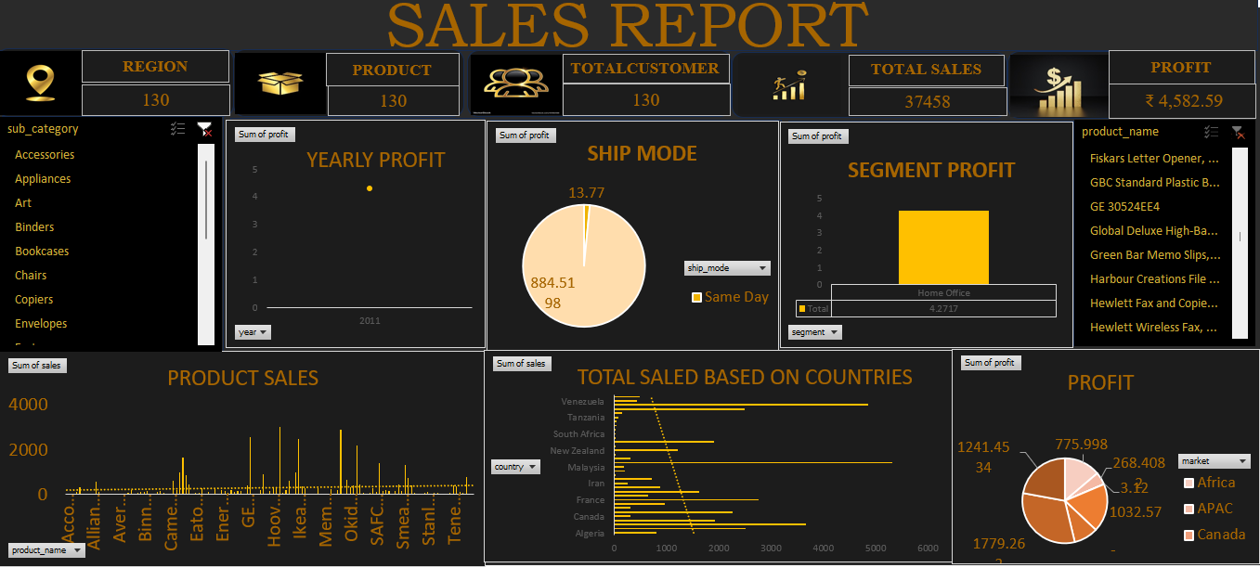

2. Database Overview
The dataset used in this project contains structured sales data with multiple attributes. It is designed to capture transactional and categorical information related to sales operations.
Key Fields in Dataset:
- Order ID – Unique identifier for each transaction
- Product Name – Name of the product sold
- Category / Sub-Category – Classification of products
- Customer ID / Name – Customer information
- Region / Country – Geographic location of sales
- Market – Broader regional classification (Africa, APAC, Canada, etc.)
- Ship Mode – Delivery method (Standard, Same Day, etc.)
- Sales – Revenue generated
- Profit – Net profit earned
- Quantity – Number of units sold
- Order Date / Year – Time dimension
Data Characteristics:
- The dataset is multi-dimensional, enabling analysis across time, geography, and product categories.
- It supports aggregation functions like sum of sales and profit.
- It is suitable for dashboard creation and business intelligence reporting.

3. Key Performance Indicators (KPIs)
The dashboard highlights the following KPIs:
- Total Regions: 130
- Total Products: 130
- Total Customers: 130
- Total Sales: 37,458
- Total Profit: ₹4,582.59
KPI Importance:
- Sales indicates overall revenue performance.
- Profit helps measure business sustainability.
- Customers show market reach.
- Products & Regions indicate diversity and coverage.
These KPIs provide a quick and clear summary of business performance.

4. Chart Analysis
4.1 Yearly Profit Analysis
This chart displays profit trends over time. It helps identify:
- Growth or decline in profitability
- Seasonal patterns
- Business performance in specific years
A stable or increasing trend indicates business growth, while fluctuations may suggest external or operational challenges.

4.2 Ship Mode Analysis
This pie chart shows profit distribution across different shipping methods:
- Standard Class contributes the highest profit
- Same Day delivery contributes the least
This suggests that cost-effective shipping methods generate more profit, while faster delivery options may reduce margins.

4.3 Segment Profit Analysis
This chart categorizes profit based on customer segments such as:
- Home Office
- Corporate
- Consumer
The Home Office segment appears to contribute significantly to profit, indicating a strong demand from small businesses or individual professionals.
4.4 Product Sales Analysis
The bar chart represents sales performance across various products:
- High peaks indicate best-selling products
- Low bars indicate underperforming products
This analysis helps in:
- Inventory management
- Product promotion strategies
- Discontinuation of low-performing items

4.5 Sales by Country
This visualization compares sales across different countries:
- Some countries show higher sales volumes (e.g., Venezuela, Malaysia)
- Others show lower engagement
This helps businesses:
- Focus on high-performing regions
- Improve strategies in weaker markets

4.6 Profit by Market
This pie chart shows profit contribution by markets:
- Africa
- APAC
- Canada
It highlights which regions are most profitable and helps in:
- Strategic investment decisions
- Market expansion planning

5. Dashboard Features
- Interactive filters (slicers) for:
  - Sub-category
  - Product name
  - Year
  - Segment
  - Ship mode
  - Market
- Real-time data updates
- Easy comparison across multiple dimensions
- User-friendly design

6. Key Insights
- A small number of products generate the majority of sales.
- Standard shipping is the most profitable delivery method.
- Certain countries dominate overall sales performance.
- Profit margins vary across segments and markets.
- Not all high-sales products yield high profit.

7. Conclusion
The Sales Dashboard successfully transforms raw data into meaningful insights through visualization techniques. It enables users to monitor performance, analyze trends, and make data-driven decisions efficiently.
The project demonstrates how business intelligence tools can enhance understanding of complex datasets and improve strategic planning. By integrating KPIs, charts, and filters, the dashboard provides a powerful solution for sales analysis.
This project highlights the importance of data analytics in modern businesses and showcases practical implementation of dashboard design and reporting.

